**1. Creating and Renaming Files/Directories Create a directory named test_dir using mkdir. Inside test_dir, create an empty file called example.txt. Rename example.txt to renamed_example.txt using mv**

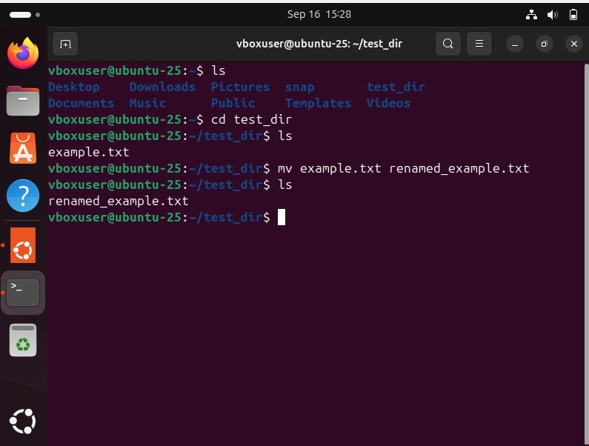

**2. Viewing File Contents Use cat to display the contents of /etc/passwd. Display only the first 5 lines of /etc/passwd using head. Display only the last 5 lines of /etc/passwd using tail.**

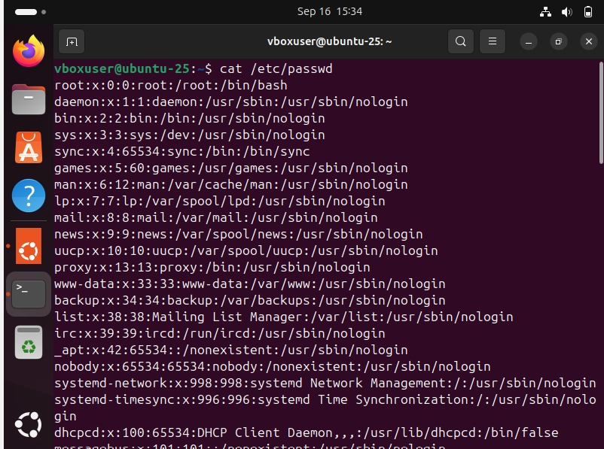

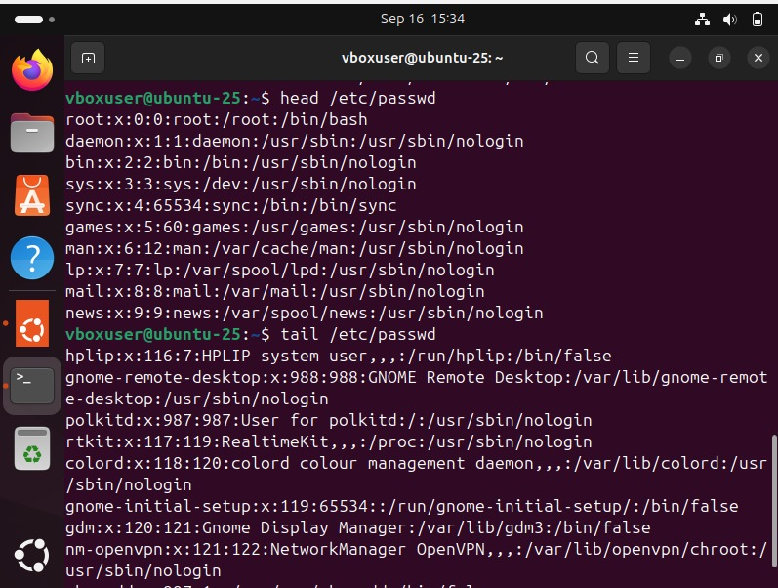

**3.Searching for Patterns Use grep to find all lines containing the word "root" in /etc/passwd.**

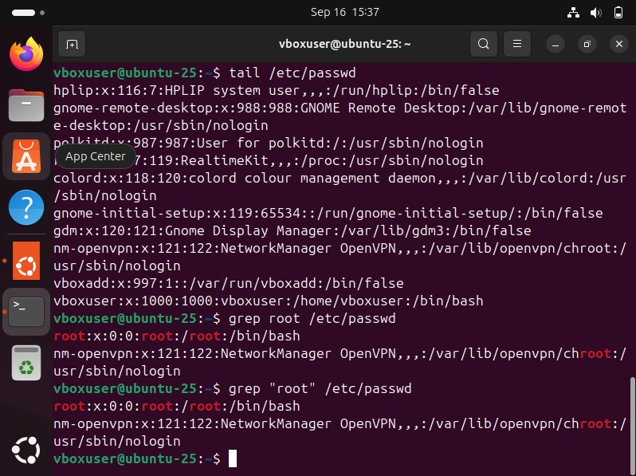

**4. Zipping and Unzipping Compress the test_dir directory into a file named test_dir.zip using zip. Unzip test_dir.zip into a new directory named unzipped_dir.**

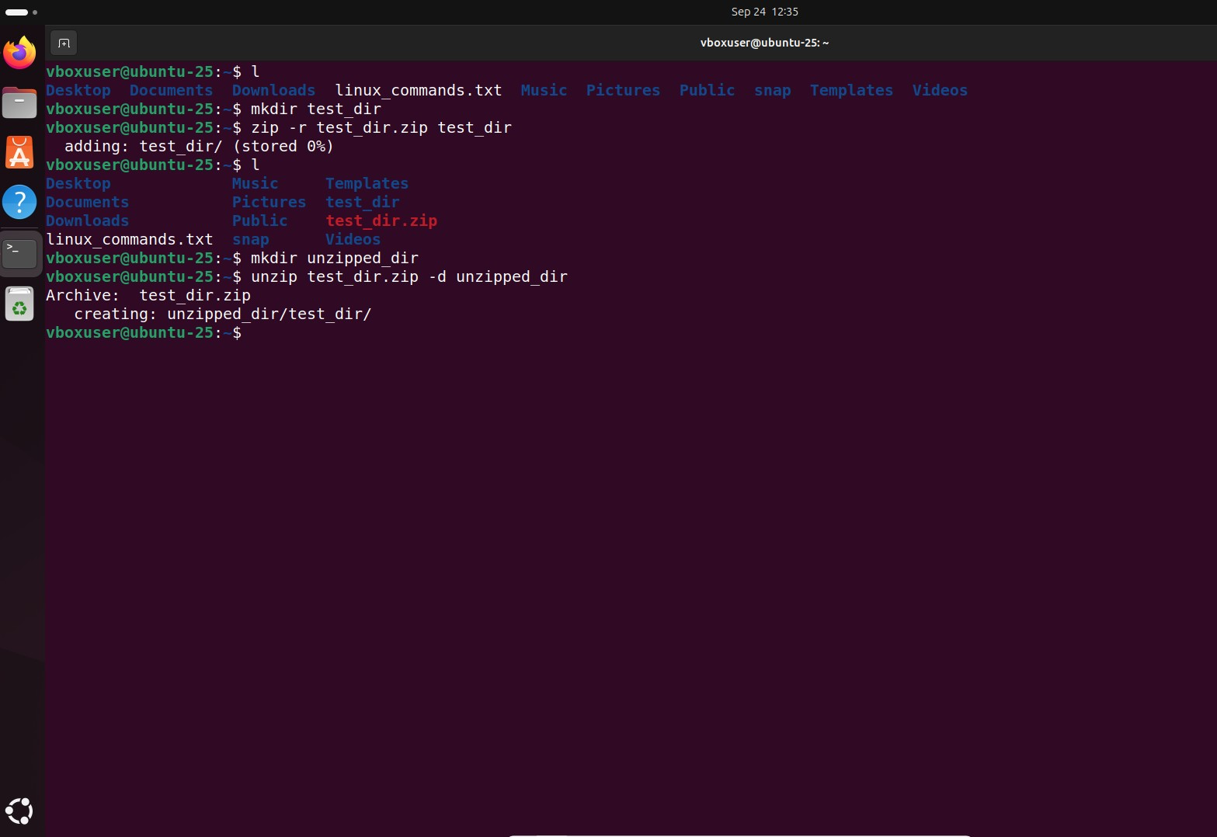

**5. Downloading Files Use wget to download a file from a URL**

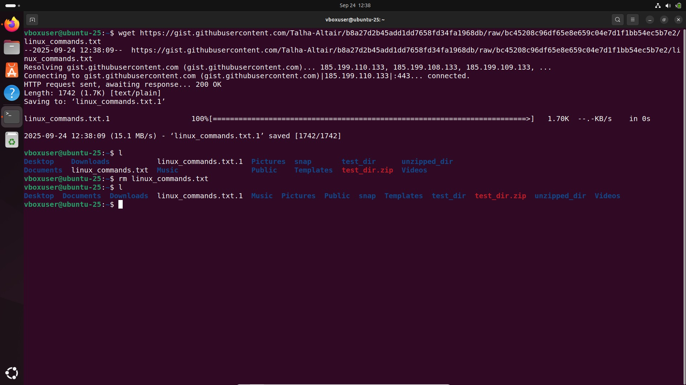

**6. Changing Permissions Create a file named secure.txt and change its permissions to read-only for everyone using chmod.**

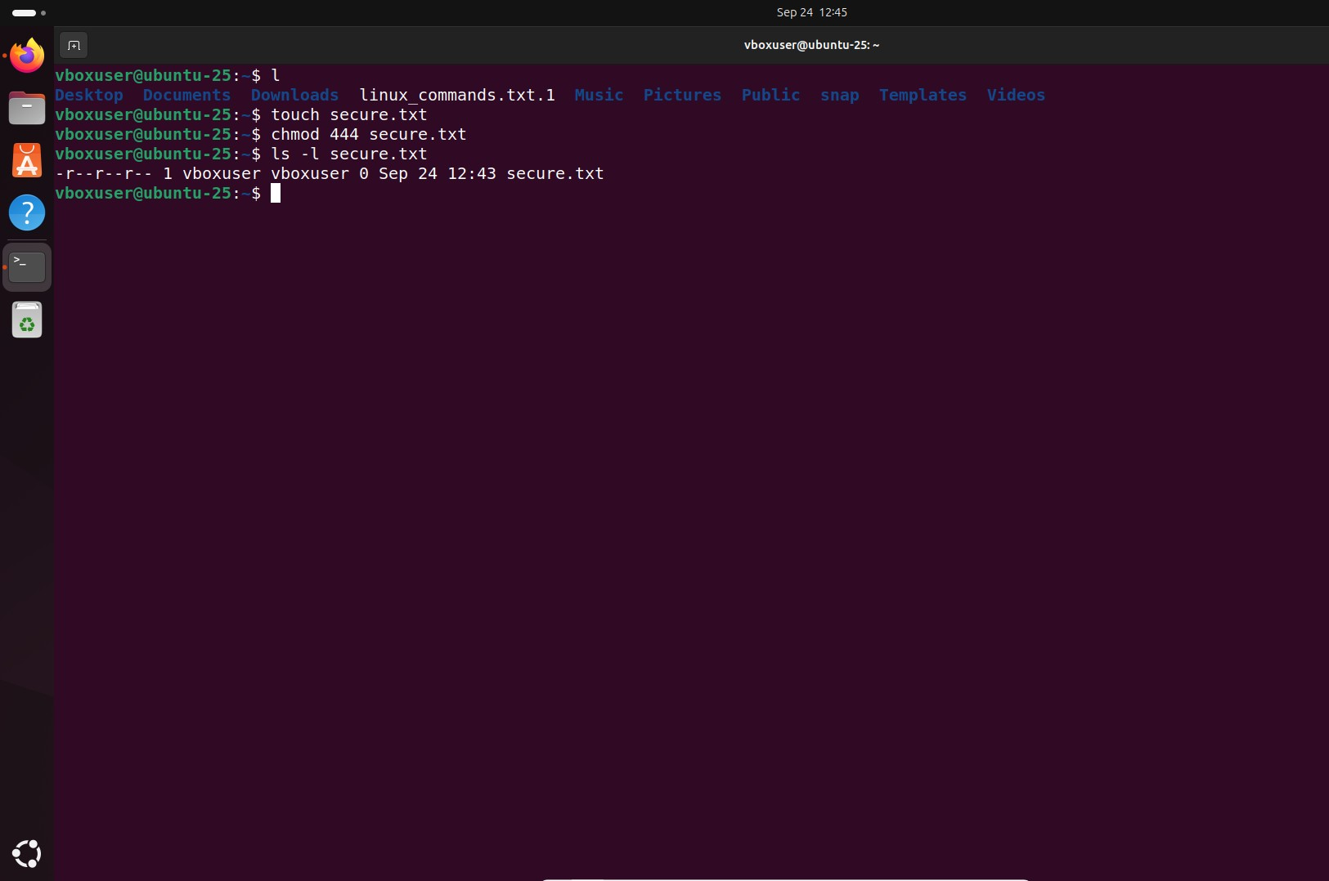

**7. Working with Environment Variables Use export to set a new environment variable called MY_VAR with the value "Hello, Linux!"**

